Ideation Phase

Brainstorm & Idea Prioritization Template

Date | 01 February 2026
Team ID | LTVIP2026TMIDS55759
Project Name | Strategic Product Placement Analysis: Unveiling  Sales Impact with Tableau Visualization
Maximum Marks | 4 Marks

Brainstorm & Idea Prioritization Template:

This brainstorming and idea prioritization template is designed to generate and organize solutions for the key problem statement:
"How might we create a centralized, visual, and interactive Tableau solution that helps retail managers and analysts understand the impact of product placement on sales?"
By involving all four team members—each with different roles and perspectives—we collected diverse ideas ranging from data visualization techniques to user experience improvements and system automation. These ideas were then grouped into common themes such as Interactive Visualization, Analytics Tools, Performance Monitoring, and Stakeholder Access.
To ensure efficient execution, the ideas were prioritized into three levels:
- High Priority for immediate implementation with high impact,
- Medium Priority for enhancements that add value,
- Low Priority for future improvements or nice-to-have features.

Step-1: Team Gathering, Collaboration and Select the Problem Statement
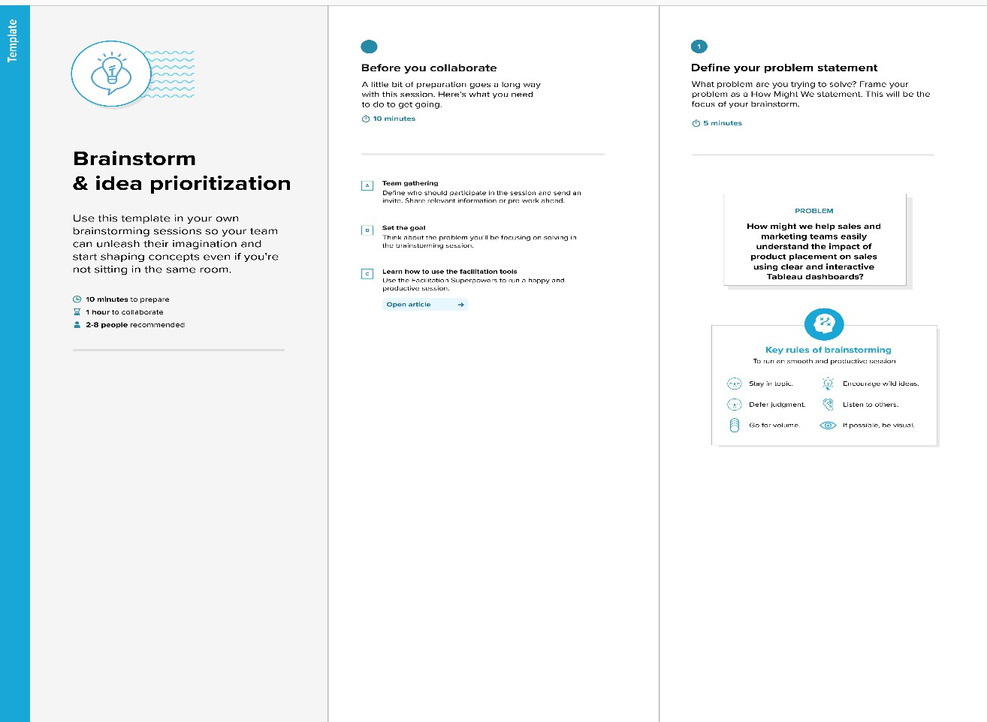

Step-2: Brainstorm, Idea Listing and Grouping

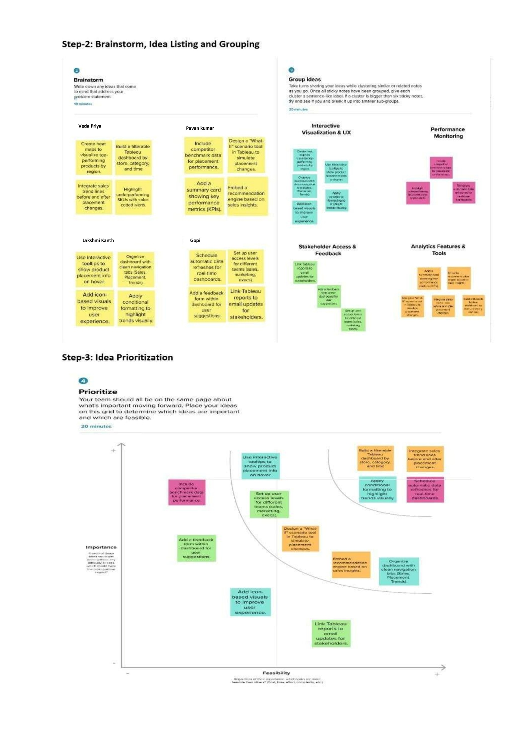

Step-3: Idea Prioritization
